**Ideation Phase**

**ResolveNow & Idea Prioritization Template**

|  |  |
| --- | --- |
| Date | 26 June 2025 |
| Team ID | LTVIP2025TMID53148 |
| Project Name | ResolveNow: Your Platform for Online Complaints |
| Maximum Marks | 4 Marks |

**ResolveNow & Idea Prioritization Template:**

*ResolveNow: Your Platform for Online Complaints*, we created an open and inclusive space where every team member, including myself, actively contributed to identifying real-world problems related to inefficient complaint systems. We encouraged creative freedom and focused on generating a wide range of ideas—both practical and out-of-the-box—with a common goal of improving how users file, track, and resolve complaints.

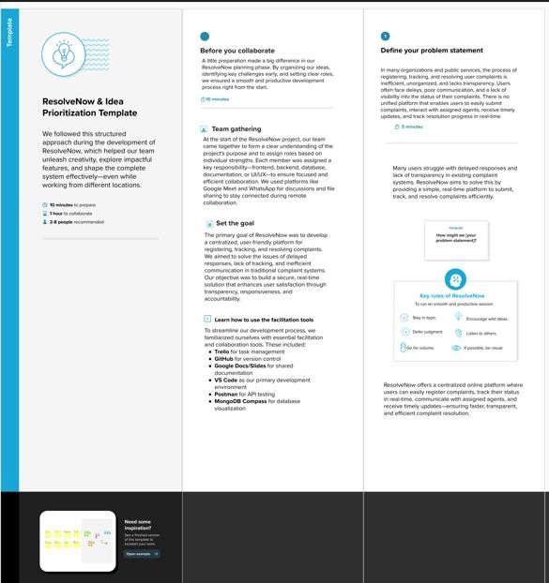

Through structured collaboration, we categorized and prioritized our ideas based on their impact and feasibility. This process helped us finalize essential features such as real-time complaint tracking, user-agent chat functionality, and a smart admin dashboard. Even though our team worked remotely, we successfully used digital tools and consistent communication to shape a robust, user-friendly solution.

We used this structure in our ResolveNow planning sessions to freely explore ideas, collaborate effectively, and shape meaningful features—even while working remotely as a team.

**Step-1: Team Gathering, Collaboration and Select the Problem Statement**

**Step-2: Brainstorm, Idea Listing and Grouping**

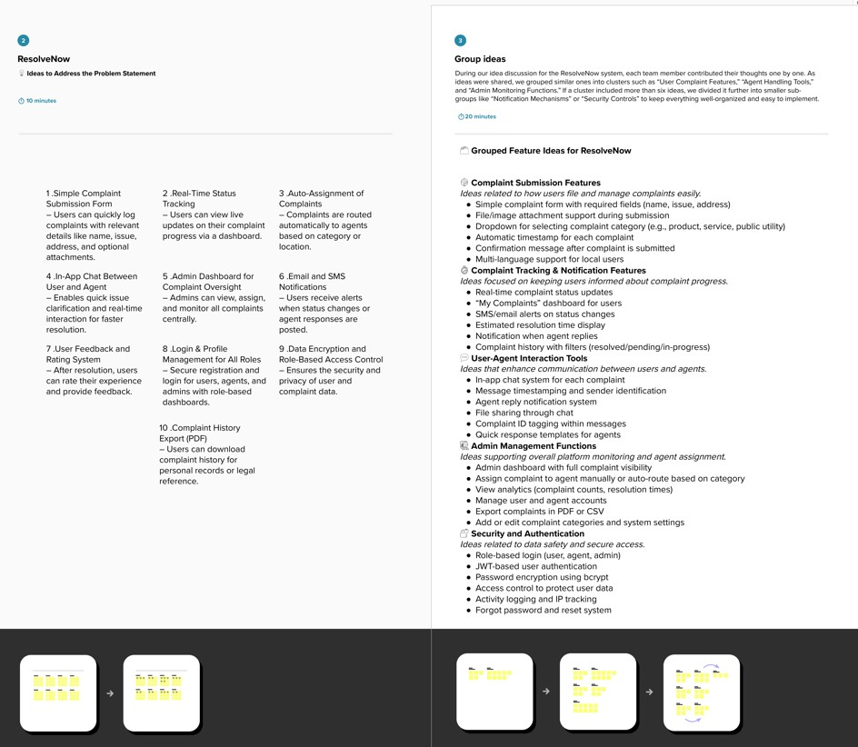

**Step-3: Idea Prioritization**

